Public- Private Dialogue Activity Block
Business events for Private Sector Organisations

BELARUS, Minsk
March 20 – march 23, 2017

As part of the East Invest II program, financed by the European Union, the Republican Union of Employers “BelUE” organizes a series of activities under the project "Public-private dialogue" with the participation of leading international experts. On March 20 – 23, 2017 in Minsk will be held the third series of events for business associations and unions - EU4Business Week. During the week, representatives of the small and medium businesses sector would be able to learn about existing funding opportunities, develop new skills for negotiation and effective networking, as well as to offer key points how to overcome the economic crisis and improve the business climate.

The week begins with a Project Development, Implementation and Fundraising Forum, which will be organized in the new practical format. Representatives of businesses and professional associations will not only learn about current technical assistance programs (EBRD, UNDP, etc), but also have a master class from EBRD: how to work with the consultants and prepare terms of reference.

During Tuesday, Wednesday and Thursday a unique Seminar "Interest based Negotiation and Mediation in Public Private Dialogue” to be provided with the assistance of the best domestic, Ukrainian and German experts. Participants will be able to practice communication skills, that really contribute to the business and social achievements.

The week will be finished by the Roundtable: "Elaboration of proposals on regional Memorandum", where BSOs and BMOs, facilitated by international experts, will form an action plan for stakeholders of public-private dialogue for priority economic proposals for Belarus as well as for the Eastern Partnership countries (Regional Policy Paper).

Participation is free. Please register under the following link: https://goo.gl/forms/e1DBnwAq7Qa2ldOr2

Venue: Republican Scientific and Technical Library Organizers:
Address: Pobeditelej pr., 7, Minsk Republican union of Employers “BelUE”
http://www.belsn.by

Co- Organizer: Belarusian Agriculture&Production Union (BelAPS)

ACTIVITIES
Monday, 20.03.2017
13:30 - 17:30
Project Development, Implementation
and Fundraising ForuM
13.30 – 14.00 | Registration
14.00 – 15.30 | SESSION: Current Funding Programs on SME sector development and Public Private Dialogue and the development of BMO in Belarus  Moderator: Sergei Zharnikov, Christian Gessl  Presentation of the projects for business associations, NGOs, small and medium-sized businesses  - European Program Horizon 2020  (Why should Belarus join these initiatives and what role BMOs can play in this!)  - EBRD  (Women in Business and Consultancy Services for SME; what role can BMOs play in this?)  - UNDP  (Belarus entry in WTO – the roles of BMO in this process)  - IFC  (Certficitaion of Food/Food Safety and important topic for BMO in access to markets for their members)  - Belarusian Fund for Financial Support of Entrepreneurs  (Great support for SMEs! What role do and can play BMO in this? How can BMO help the fund to offer even better adapted services through Public Private Dialogue)
15.30 – 17.00 | PRACTICAL SESSION:  EBRD: master class on how to work with the consultants and prepare terms of reference.  Success story.
17.00 – 17.30 | Networking and Coffee
Tuesday, 21.03.2017 – Thursday, 23.03.2017

09.00 – 17.30
3-days Seminars and Workshops
on NEGOTIATIONS AND MEDIATION

Today, the ability to negotiate is one of the most essential and valuable skills in any profession. After all, the ability to communicate with clients and partners for most companies and organizations is the key to competitiveness and a guarantee of success. It becomes possible and profitable to build long-term and stable cooperation. Skills of effective negotiator allow you to work effectively with the content of the question, to competently manage the process and relationships.
Training objectives include developing skills of a successful negotiator, mastering basic mediation skills and developing and expanding the application of mediation skills in a wide range of negotiations. Teaching methods are group discussion, brainstorming, exercises, business games, case study, video analysis, modeling of practical situations. The seminar involves a lot of practical simulations, in which participants will exercise obtained knowledge and new techniques of dispute resolution and negotiation.
Tuesday, March 21, 2017
Time | Content | Trainer
09:00 - 09:30 | Registration
09:30 - 09:45 | Welcome – Introduction | Volker Stoetzner  Galyna Yeromenko  Liliya Vlasova
09:45 - 10:30 | Session 1: Model of negotiations. Negotiator's competencies. Harvard Negotiation Model. Presentation. Video. | Volker Stoetzner  Galyna Yeromenko  Liliya Vlasova
10:30 - 11:00 | Coffee Break
11:00 - 12:30 | Session 2: Dealing with interests. Types of interests. Presentation. Video. Exercise. | Volker Stoetzner  Galyna Yeromenko  Liliya Vlasova
12:30 - 13:30 | Lunch Break
13:30 - 15:00 | Session 3: From interests to options. Identification of stakeholders. Widening the field for negotiation. Presentation. Exercise. | Volker Stoetzner  Galyna Yeromenko  Liliya Vlasova
15:00 - 15:30 | Coffee Break
15:30 - 17:00 | Session 4: Dealing with stakeholders: who, why, how. Presentation. Exercise. | Volker Stoetzner  Galyna Yeromenko  Liliya Vlasova
17:00 - 17:30 | Wrap-up

Wednesday, March 22, 2017
Time | Content | Trainer
09:00 - 09:30 | Registration
09:30 - 10:30 | Session 5: Communications. Working with perception. Presentation. Exercise | Volker Stoetzner  Galyna Yeromenko  Liliya Vlasova
10:30 - 11:00 | Coffee Break
11:00 - 12:30 | Session 6: Negotiator's Skills. Rhetoric Skills: dealing with questions, active listening, framing, reframing, paraphrasing. Presentation. Exercise. Video. | Volker Stoetzner  Galyna Yeromenko  Liliya Vlasova
12:30 - 13:30 | Lunch Break
13:30 - 15:00 | Session 7: Negotiation for Coalitions. Coalitions Forming. Presentation. Video | Volker Stoetzner  Galyna Yeromenko  Liliya Vlasova
15:00 - 15:30 | Coffee Break
15:30 - 17:00 | Session 8, The balance of power. Sources of power in negotiations. Presentation. Video | Volker Stoetzner  Galyna Yeromenko  Liliya Vlasova
17:00 - 17:30 | Wrap-up

Thursday, March 23, 2017
Time | Content | Trainer
09:00 - 09:30 | Registration
09:30 - 10:30 | Session 9: Alternatives (Plan B).Presentation. Video | Volker Stoetzner  Galyna Yeromenko  Liliya Vlasova
10:30 - 11:00 | Coffee Break
11:00 - 12:30 | Session 10: Managing of the Process. What we can learn from mediation process. Presentation | Volker Stoetzner  Galyna Yeromenko  Liliya Vlasova
12:30 - 13:30 | Lunch Break
13:30 - 15:00 | Session 11: Lobbing. Presentation. Exercise | Volker Stoetzner  Galyna Yeromenko  Liliya Vlasova
15:00 - 15:30 | Coffee Break
15:30 - 17:00 | Session 12: Presentations | Volker Stoetzner  Galyna Yeromenko  Liliya Vlasova

Experts / Speakers / Consultants

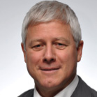 | Christian Gessl is since March 2015 developing the Public Private Dialogue activity within the EU Project “East Invest 2”. He is one of the representatives of UEAPME in the Project Management Team of East Invest 2.  For the last 26 years, he was working for the Austrian Federal Economic Chamber representing the interests of the Austrian Exporters. He worked as Deputy Commercial Counsellor in South Korea, the Russian Federation and Belgium, from 2000 – 2007 as Commercial Counsellor in Ukraine and from 2007 – 2010 as Commercial Counsellor in Barcelona.  Form 2010 – 2015 he was Director for Central Europe and the Baltics in Advantage Austria. He organized conferences like the CEE LAC Business Forum bringing together companies from Latina America and Central Eastern Europe, the Danube Region Business Forum on Value Chains in the Argo-Food Business and Forums on Touristic Infrastructure. He worked on the topic of Hidden Champions in Austria demonstrating their importance for the success of the Austrian economy. He participated in different EU projects as expert and trainer on organizational development in Business Membership and Business Support Organisations. Christian Gessl has a University Degree in Business Administration from the University of Innsbruck and he is an honorary doctor of Lugansk Pedagogical University.
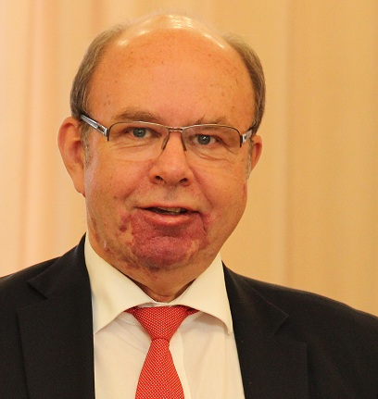 | Volker Stoetzner, International Expert in SME- Development projects and Certified Business Mediator (IHK- Germany) and trainer.  Graduating from Moscow Institute of International Relations in 1981 he was working as an International expert in Public Associations and Private German and Japanese Business Companies. During the last 15 years he was working for German and EU Associations as expert, trainer and project director in various Consulting projects, mainly in CIS- countries- such as Moldova (2005-2012, 2014-2015), Kazakhstan (2007-2010) Ukraine (since 2010) and Kyrgyzstan (since 2014). Since 2013 he is working in the field of Business Mediation, where he coordinates the implementation of Business Mediation as service for Business Associations, organizes and provides training, based on German standards and provides seminars for Business associations and private companies. Since 2015 Volker Stoetzner has provided mediation trainings in Ukraine, Kyrgyzstan and Moldova. Together with the Ukrainian Mediation Center (UMC), the German Munich Chamber of Commerce Training Course on Business Mediation is beeing carried out with more than 80 graduated Business mediators with German Certificate. Also, 5 Mediation Centers at Ukrainian Chambers of Commerce, providing mediation consulting, trainings and mediations, have been established and are working successfully.
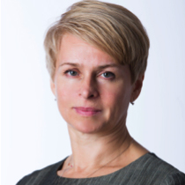 | Galyna Yeromenko is a Ph.D. In Law and the Director and a Trainer at the Ukrainian Mediation Centre (kmbs). As of her specialization, she is a scholarship holder of International Institute for Unification of Private Law (Rome, Italy), in 2001 participated in professional development program organized by the above mentioned institute. In 2004 she became the award co-winner (award after Yaroslav the Wise) granted by the Academy of Legal Sciences for Manual on Civil Law. Galyna participated in educational programs on business education development: INSEAD, (France), Irish Institute of Business (IMI, Ireland), Chartered Institute of Marketing (CIM, Great Britain), etc. In 2010, Galyna was recognized as Weinstein fellow at JAMS Foundation (USA). Also, she is a member of an international network of trainers in mediation (CEDR trainers-network). Galyna was accredited by CEDR (UK) as a mediator in accordance with international standards.  Since 2008 she is the Manager of the Ukrainian Mediation Centre under the Kyiv-Mohylyanska Business School. In April 2012 Galyna was appointed Chairman of the Commission for Mediation and Advisor to the President of ICC. She is a senior researcher at the Institute of State and Law after V.M. Koretsky of the National Academy of Sciences of Ukraine. She has experience as a mediator in commercial, institutional, family disputes and conflicts. As a coach, she conducted trainings for mediators in Kazakhstan, Kyrgyzstan and Belarus.  In 2013 Galina’s case "Collaboration Competence Development" has been conditionally accepted subject to being revised for presentation to the 6th Conference of the Euro Med Academy of Business (Portugal). She was honored with the "Era of Mediation" award "For achievements in theoretical and applied research technologies of alternative dispute resolution”.
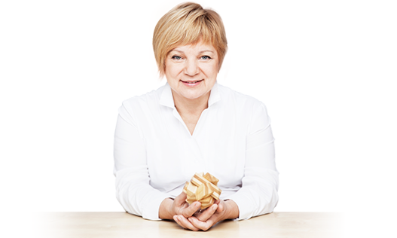 | Liliya Vlasova is a Ph.D. In Law and the Senior Partner at the Vlasova Mikhel & Partners Law Firm  Education: Belarussian State University (law faculty), Law Degree, Ph.D. in Law.  St. Petersburg University - Russian-American program on conflictologe, 160 hours, 2009.  Present position: Founder of the Center of mediation and negotiation, Minsk, 2012; Director and Head of Mediation practice of Law firm «Vlasova, Mikhel and Partners».  Founder of mediation in Belarus. The head of the pilot project for the promotion of mediation in the resolution of commercial disputes (Minsk, 2011-2012). International mediator. Included in the international list of mediators from Russia, Ukraine, and Belarus. Recognized as the best mediator of the year by St. Petersburg's Mediators League (2012). Awarded by the Belarusian Union of Lawyers for contributing to the development of mediation in Belarus (2013).  Liliya are recommended by Chambers Europe 2016 as a high-level professional in practice of Alternative Dispute Resolution. As mediator Liliya has conducted over 150 commercial and other mediation procedures. Liliya has developed an education program of mediation. As a trainer of mediators, Liliya conducts trainings and practical courses in Belarus and other countries.
Participation is free.
Registration is mandatory at: https://goo.gl/forms/e1DBnwAq7Qa2ldOr2

Venue: Republican Scientific and Technical Library
Address: Pobeditelej pr., 7, Minsk
Contacts: Alena Lugovtsova, coordinator
+375 29 6236006 lugovtsova@sbmt.by

